Board and members of HGI bring over 200 years of experience from their searches for their “perfect brace” and share what they have learned from their own personal quests. Although most of them are polio survivors living with a long-term neuromuscular disorder, what they have learned can apply, to some degree, to anyone who needs lower extremity bracing whether it is the result of a stroke, an accident, an autoimmune disorder or any other long-term disability that results in the need for bracing.

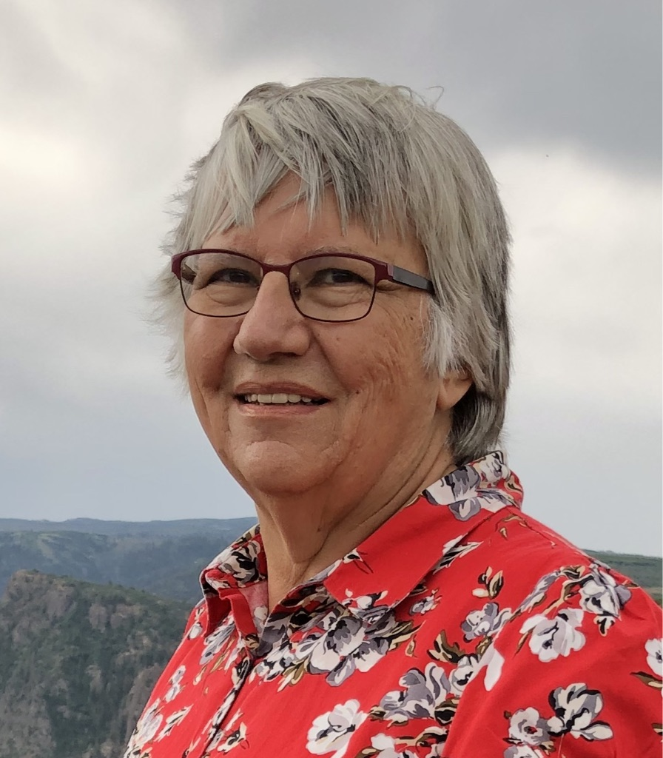 Dr. Marny Eulberg, M.D., of the Mountain and Plains Post-Polio Clinic, wore a leg brace from ages 4 to 13 years old and had to go back into bracing at age 39. She initiated her own search when she learned that to best meet her needs, she would have to either go into a long-leg (KAFO) conventional brace or find a custom alternative that would meet her needs. After she initiated her search and found her “best brace,” she founded HGI and brought four others along to share their journeys.

 Jim Dean, a retired attorney, did not wear a leg brace until he was in his 60s. Since then he has tried three different types of braces including a conventional brace and two custom braces. His results have varied, but the custom braces have provided more assistance than the conventional brace.

 Margaret Hinman, a retired educator, has been in and out of bracing since she was 11 years old. After wearing a long-leg brace (KAFO) for 5 years, she quit bracing for over twenty years, and only went back to bracing when she hurt so bad she could not walk. Her current “best brace” is over 10 years old and acquired after trying almost every conventional and custom brace she could find that did not work.

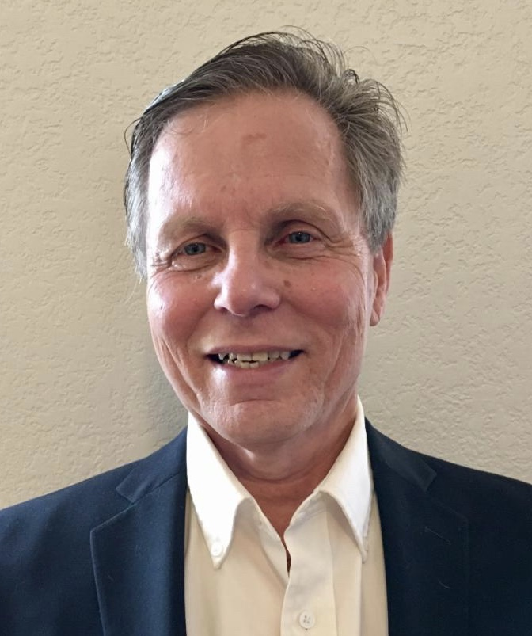 Mike Mrozowicz has never walked without a leg brace. He has always worn a custom brace, including trying an electronic exoskeleton which did not meet his needs. He has been using his current “best brace” for over 7 years.

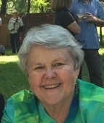 Karla Stromberger, a retired pediatric physical therapist, went into bracing as a mature adult. She has braces on both legs, one a short leg brace (AFO) and one a long leg brace (KAFO). Her “best braces” have allowed her to be physically active, hiking, walking on the beach, and playing bocce ball.

 Steve Medberry D.P.T—a practicing physical therapist, wears two short leg braces (AFO’s) as a result of an autoimmune disorder that he contracted in his late teens. He is still looking for his “best braces.”